**1. Write a Python script that takes two integers as input and calculates their GCD using the Euclidean algorithm.**

**Based on the result, determine whether these numbers are co-prime.**

**If they are co-prime, print a message indicating that they can be used in cryptographic key generation; otherwise, print a message that they are not suitable.**

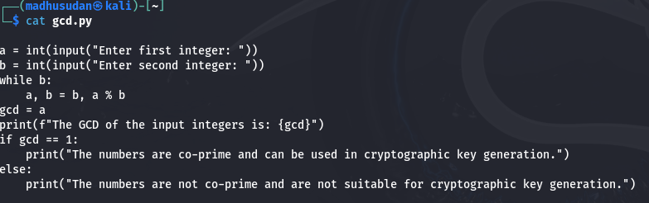

**Output**

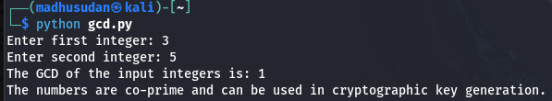

**2. Write a python script to take two integer values (number (n) and modulo (m)) from the user and find the modular inverse using extended Euclidean algorithm.**

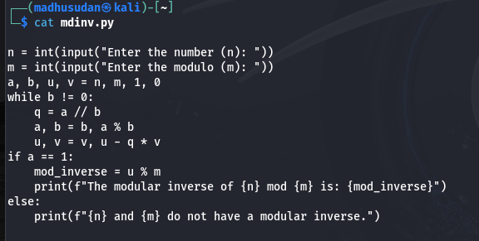

**Output**

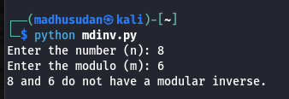

**3. Write a Python script that generates a random binary number of length 100. The output should be a string of 100 binary digits (0s and 1s).**

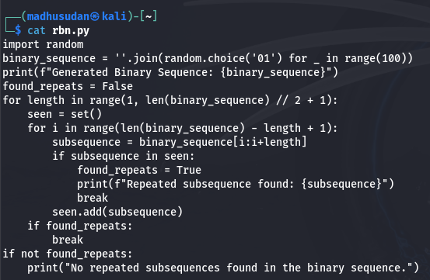

**After generating the binary sequence, implement a function to check whether any subsequence of digits repeats itself within the sequence.**

**Output**

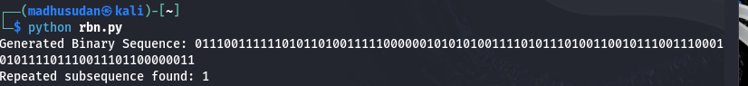

**4. Write a Python script that performs the Golomb test to the numbers provided below.**

**101011001010**

**111111000000**

**The script should**

**- Perform and print the results of the three Golomb tests on the sequence.**

**- Print a message indicating whether the sequence passes the Golomb tests or not.**

**Output**